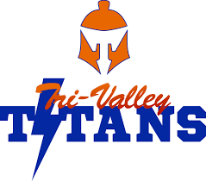
Football Roster 2018

Number | Titan | Grade

3 | Jarret Mink | 10
8 | *Jayden Mink | 12
10 | *Orion Southwick | 12
11 | Charlie Gay | 9
12 | *Michael Carpenter | 12
15 | Emmett Walker | 9
17 | Ty Barnett | 11
20 | Lukas Langforth | 11
22 | Kayden Harvey | 11
25 | Reed Thulander | 12
34 | Jeremy Damon | 10
36 | *Cody Nixon | 12
42 | JR Leatherman | 10
48 | Hudson Hart | 11
55 | Tayden Murray | 12
56 | Jeremy Moye | 10
58 | Johnny Carpenter | 11
74 | Jason Damon | 12
78 | Timon Bode | 11
*Team Captains

Head Coach/OC: Bob Johnson Superintendents: Ed Schumacher and KyLee Morris
Assistant/DC: Scott Midgley Athletic Directors: Sara Kindall and Jennifer Uhlenkott
Assistant OL/DL: Bobby Post School Colors: Blue and Orange
Team Manager: Boden Meyer

